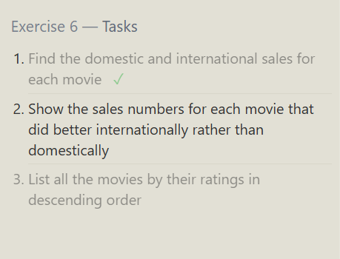

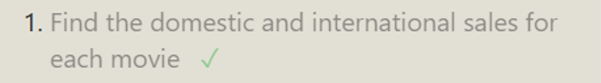
QUERY:

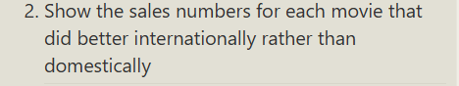
QUERY:
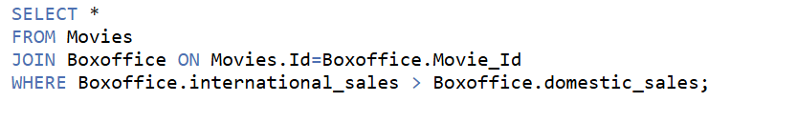

QUERY:


